To One Another Ministries is
Recruiting New Members

People we are looking for
- College, Recent graduates, young professionals, people who are seeking to make a meaningful impact by what they do
- Single or Married
- Ages roughly between 18 and 39

Membership Qualifications
- You do not believe in God or His existence; or you may have questions about the Bible or what God can do for you
- You attend church, but are unsure how He relates to your life, work, and pursuits. You have many questions about God
- You feel confident about who God is, and you wish to help those that do not know God to truly experience Him
- You want to connect your life (work, pursuits, relationships) with faith by sharing lives with one another in a community of acceptance and develop a deeper relationship with God
To One Another Ministries is
Recruiting New Members

People we are looking for
- College, Recent graduates, young professionals, people who are seeking to make a meaningful impact by what they do
- Single or Married
- Ages roughly between 18 and 39

Membership Qualifications
- You do not believe in God or His existence; or you may have questions about the Bible or what God can do for you
- You attend church, but are unsure how He relates to your life, work, and pursuits. You have many questions about God
- You feel confident about who God is, and you wish to help those that do not know God to truly experience Him
- You want to connect your life (work, pursuits, relationships) with faith by sharing lives with one another in a community of acceptance and develop a deeper relationship with God

Come and Belong

E

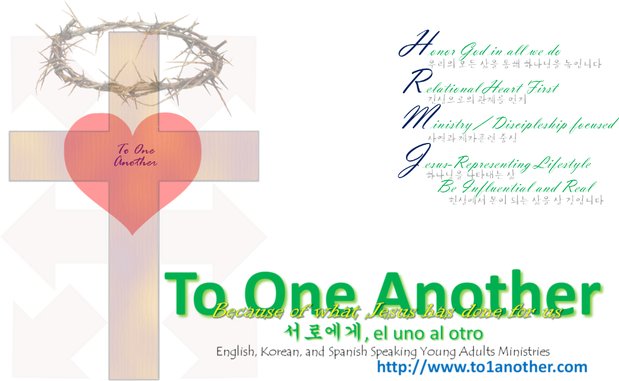

Join us

Come and Belong

E

Join us

